NC SBRO MINUTES 2012
September 8, 2012

North Carolina Youth Rugby Union

P.O. Box 49476,

Charlotte, NC 28277
http://www.ncyru.org/

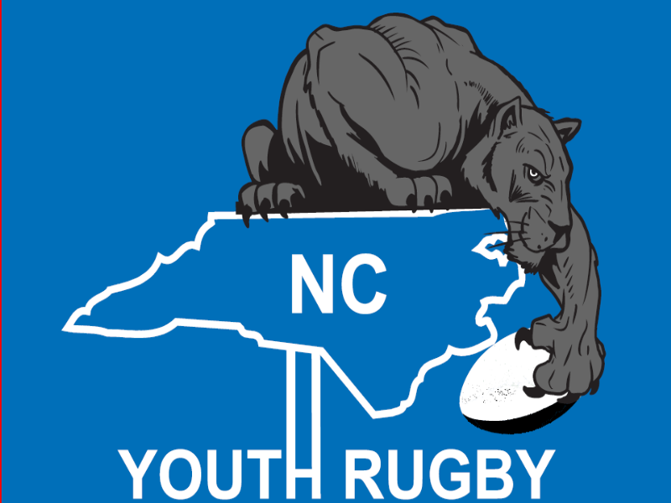

- President’s Annual Report

- The Board of Directors – their role and official vote
Discussion: Board of Directors –
Recommendations –
To make sure the BOD is not involved with day to day operations, there needs to be clear structure and strategic direction. The BOD will create a vision and oversight for rugby in NC.
They will meet at least 4 times a year – BOD to confirm dates for meetings
- BOD and Executive Board to meet and decide mission and vision
- Regional Directors have been selected to represent all regions in NC
- Board Members have expertise in different areas that will open doors and help rugby in NC
- Treasurer needs to be established to oversee finances of Ex. Board
Executive Board – Need to create a mission and carry out BOD vision. The EB is responsible for the day to day operations of rugby in NC.
If members have issues or problems, they will still need to send their issues to the Executive Board, not to the BOD.

Motion: to amend the NCYRU bylaws in order to establish the nominated board of directors (see President’s Annual Report for more details). - Motion passed

Spring Festival
Discussion:
We need to establish a premier division and invite highly ranked HS teams to the NCYR Festival (e.g. Gonzaga, Xavier, Jesuit);
We need to establish good communication and work collaboratively to build on the momentum gained from the 2012 Festival.
Motion: to create executive committee, headed by Ramon Villacura to run the 2013 spring tournament – Motion Passed

Other Points of Discussion from President’s Report:
- 7s vs 15s – Channel players to the two versions of the game so there is no conflict in recruiting players.
- Coaching – NC to host our own coaching clinics, clubs/schools to work together to improve coaching, mentorship program needs to be established, observing practices – Fall conference

- Referee committee to continue to doing their great work.

- All Stars – Motion: for Steve Burr to continue to head the All Star Committee, with a strong recommendation of Dave Hamilton as Head Coach. The All Star Program will run as an semi-autonomous 15s Select Side – Motion Passed
- USA Rugby is realigning geographic areas – we know that we will be with SC but are not sure about what other states will join us.
- Treasurer’s Report
NCYRU had a very successful year. We started with $2,000 and now we have $5,800 in the treasury. This was mainly due to the Spring Festival which netted $1,700 and also due to the All Star Program operating within their budget and having money left over for expenses for next year.

Clubs will not have to pay the $150 fee to USA Rugby for club registration for the 2013 rugby season. The SBRO has paid $3,000 fees to USA Rugby to cover these costs. NCYRU will let USA Rugby know which clubs will be registered for the 2013 season
Motion: to continue to collect $5 fee for the CIPP 2013. (Last year NCYRU had 870 players, coaches and refs CIPP with USA Rugby). Motion passed.

- Secretary’s Report
It is important that NCYRU continues to operate with open communication and transparency to all members in various locations in NC through emails and the website.
If anyone would like to post something on the site or send information to all our members please let me know.

- A look at the By-Laws for possible discussion and amendment
Motion: to have proxy votes available for members who can’t attend AGM – Motion Passed
Motion: to change number of votes from 2 per club to one – Motion Passed
Motion: to allow any member to stand as an officer on the executive committee. Vote for officers will be conducted every year at AGM – Motion Passed

Full Member Clubs are entitled to be represented by one (1) Club Voting Representative (CVR) from within the Individual Members of their club.
The seven (7) member Board will be up for election at the AGM every year.

All Directors shall serve a term of one (1) year. All terms of office shall commence at the conclusion of elections at the AGM and shall run through the conclusion of elections at the next years AGM.

A Director may choose to be re-elected to serve more than one (1) consecutive year term.

- Competitions – the playing side – venues for games
Motion: to develop a committee that will create a structured 7s competition NC that leads up to the USA Rugby 7s. – Motion Passed.
Fall Rugby – club and school rugby to combine to make 7s teams

- Discipline and the etiquette of the game – re-instating a parent led spirit of the game committee (Ron Butcher’s role in the early days)
Continue discipline committee for players, coaches, referees, clubs for any SBRO matters.
Clubs need to have a parent in charge of rugby etiquette – “culture keeper”
Send CK nomination to the SBRO

- USA RUGBY conference call - Dave McCann (Coach Development Director) will explain the changes in coaching certification 1:00-1:30pm
See powerpoint attachment sent with AGM minutes.
NCYRU needs to create a list of coaching certifications – what is the need for coaching certifications?

- Money and Fundraising - The Rugby Ball, The Spring Festival, Select Side
SBRO has formed NCYRF – Their goal is to provide money for youth rugby in NC for existing clubs and establishing new clubs. Also for Scholarship money, rugby tours – Grand Cayman? and eventually College scholarships.
Need to promote Rugby Ball. Need to sell tickets in advance.
Door sales $150.00

- Nominations and Elections
Nomination for Secretary – Nomination for Matt Henry – voted on the Board
Vice President – Nomination for Conrad Wood – voted on the Board
U19 HS Boys Representative – James Larkin – voted on the Board
Junior Representative – Andy Thomas – voted on the Board
Women’s Representative – Motion to leave the WR position vacant until we have nominations

- New Business
Motion: to rotate the meeting locations within NC- Motion Passed

Meeting closed at 2:10

